CSCE 313 Programming Assignment 5

Data Server Moved Out

Aldo Leon Marquez UIN: 326004699

The purpose for this assignment is to introduce us to another type of comunication, this time using nertworks. By setting up a local server that can be accessed from other terminals and used at the same time. To do so I will use most of my code for PA3 but replace the TCP with sockets. A class called Network Request Channel(NRC) will be used to create and access the server.

Few Changes had to be done to get the full implementation, The main changes being: The new NRC class, the change to using sockets instead of file descriptors(no need for in and out file descriptors), some minor changes to get the file size, taking the server sexecution from the client etc.

The Final implementation works as expected.

**Results**

One client requesting all data points

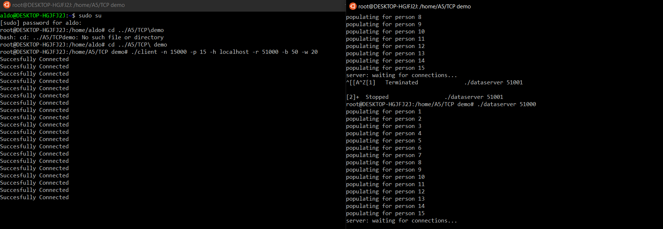

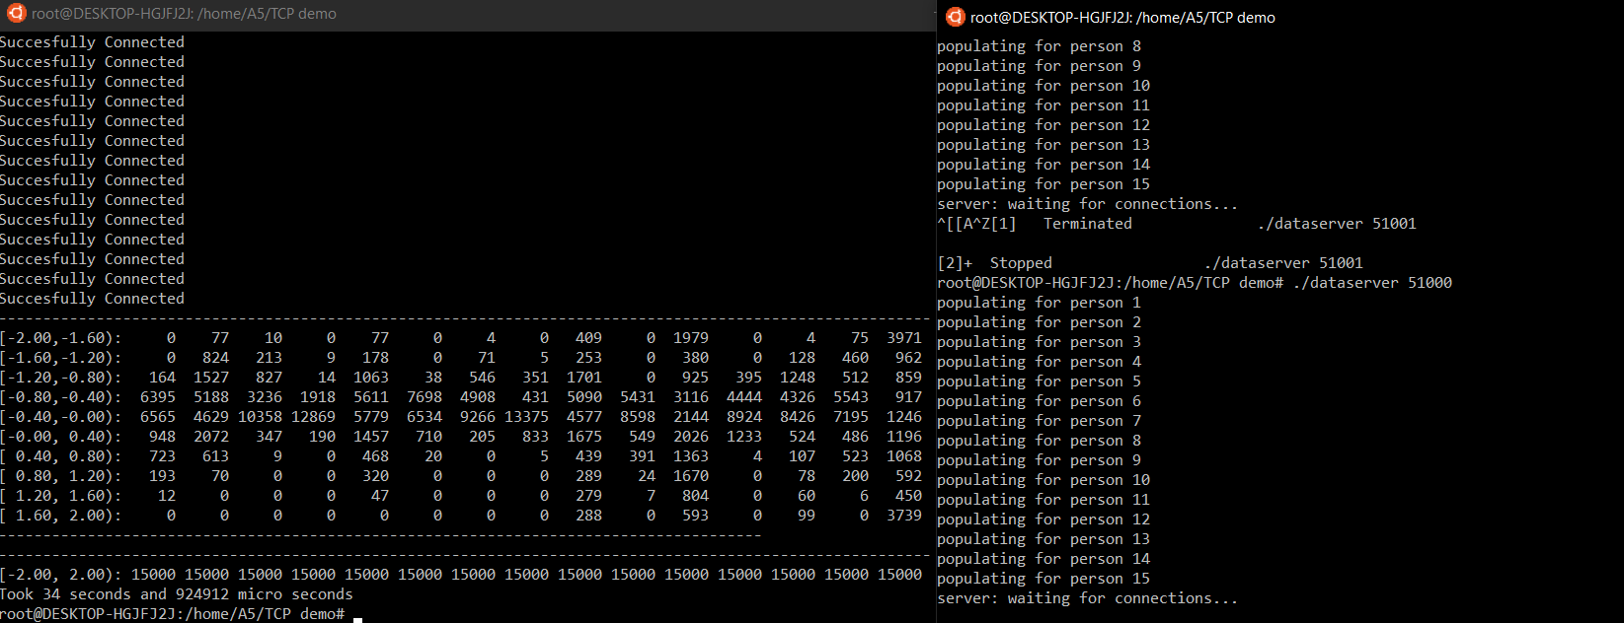

Four Clients requesting all data points

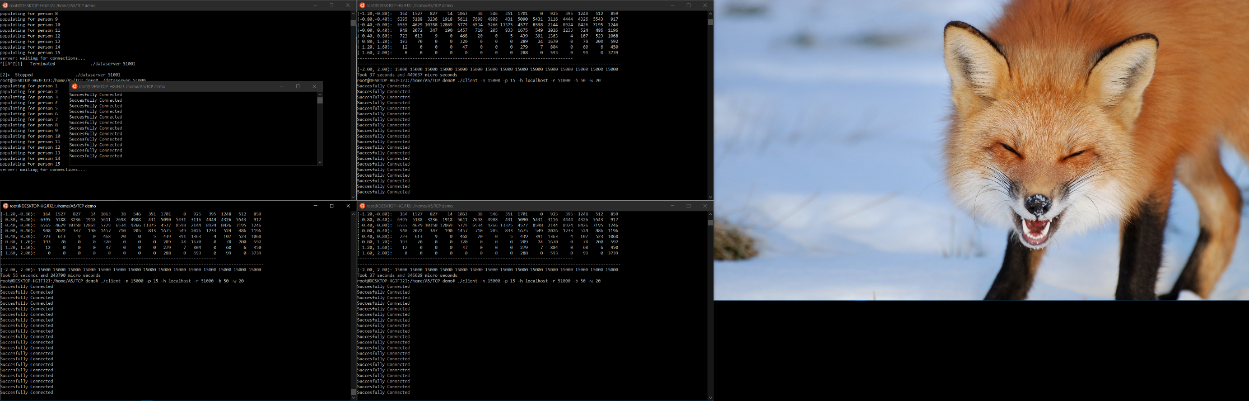

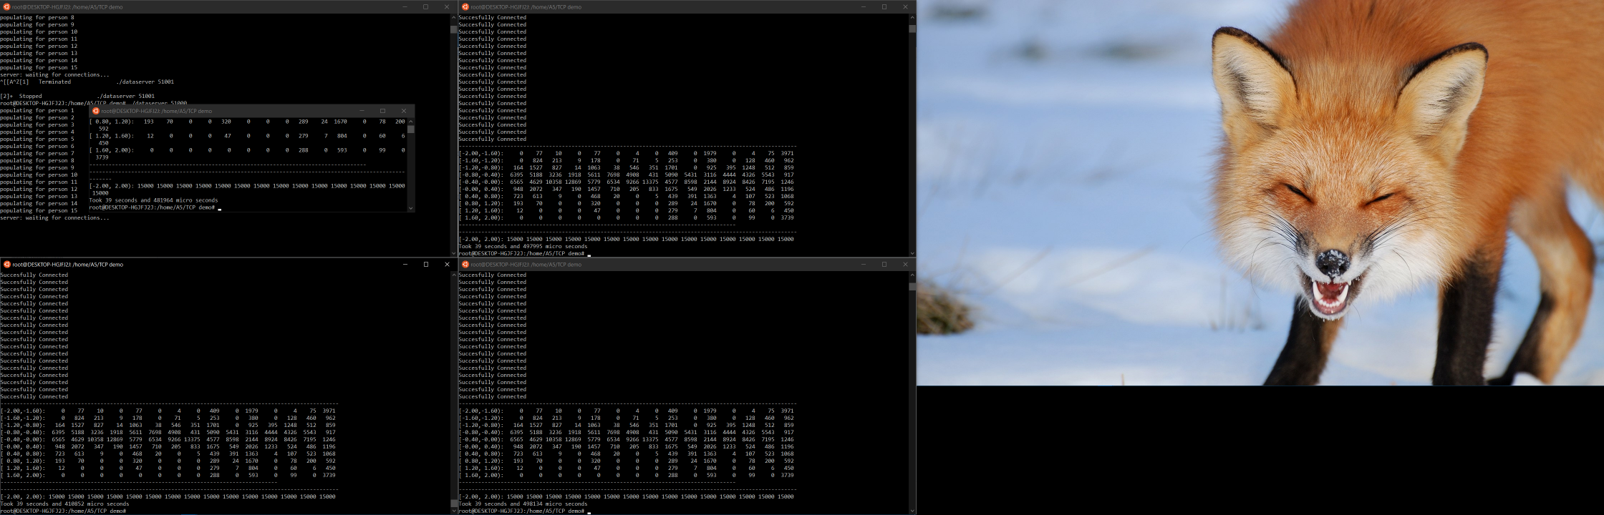

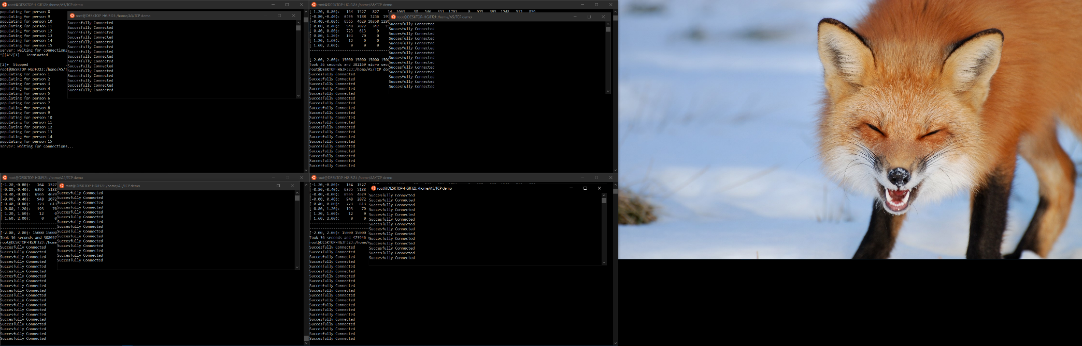Seven clients requesting all data points simultaneously

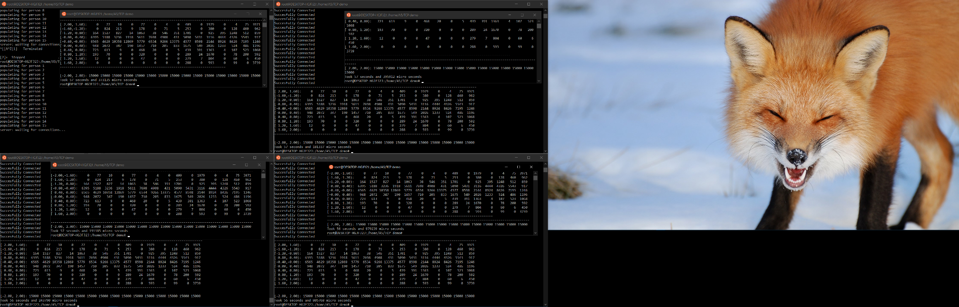**Performance and Diminishing returns:**

The performance using this method is almost identical to the performance obtained using FIFO in the assignment 3, except from some particular cases and really small-time differences.

The same data that was captured in PA3 was captured for this assignment plus a new test using multiple clients at the same time, for this data a maximum of 7 clients were used. Here are the graphs of said data

This first Graph shows the performance of running a single client with a variable number of worker threads. The performance of is almost identical to the performance of PA3, just a tad slower by about a second. Performance remains pretty solid until around 1500 worker threads.

This Second Graph shows the performance of transferring a file using different buffer sizes, except from using a buffer of size 1 the performance is the basically the same

Next up is the graph of the File Transfer using different number of workers. The Performance for this task was almost identical to the performance of PA3 with the exceptions for the cases of 4000 and 5000 worker threads

For the last test more than one client was used simultaneously. By setting up a small number of worker thread and by requesting all data points I ran simultaneously from 1 to 7 clients in multiple terminals. The results indicate that performance seems to slow down linearly, bit not too drastically.